LAB 4: A* SEARCH
Campus Routing Graph
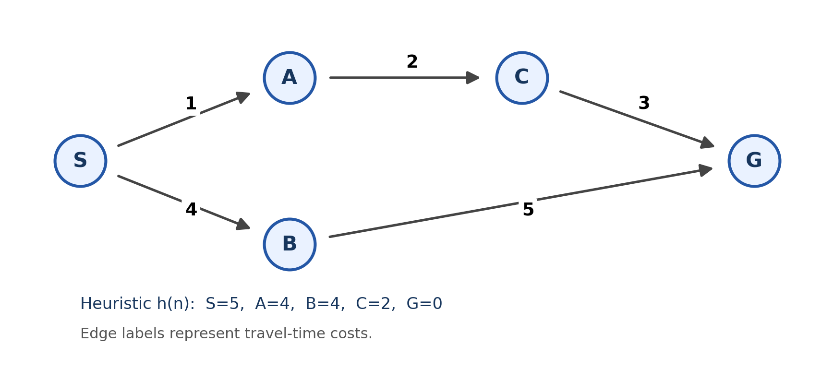

A* Python Code
import heapq

graph = {
"S": [("A", 1), ("B", 4)],
"A": [("C", 2)],
"B": [("G", 5)],
"C": [("G", 3)],
"G": []
}

h = {"S": 5, "A": 4, "B": 4, "C": 2, "G": 0}

def astar(graph, h, start, goal):
# Queue priority: lowest f, then lowest g, then node name.
pq = [(h[start], 0, start, [start])]
best = {start: 0}
processed = []
expanded = []

while pq:
f, g, node, path = heapq.heappop(pq)

# Ignore outdated entries in the priority queue.
if g != best.get(node):
continue

processed.append(node)

# The goal is processed but is not expanded.
if node == goal:
return g, path, processed, expanded

expanded.append(node)

for next_node, edge_cost in graph.get(node, []):
new_g = g + edge_cost

if new_g < best.get(next_node, float("inf")):
best[next_node] = new_g
new_f = new_g + h[next_node]
heapq.heappush(
pq,
(new_f, new_g, next_node, path + [next_node])
)

return None, [], processed, expanded

cost, path, processed, expanded = astar(graph, h, "S", "G")

print("Shortest path:", " -> ".join(path))
print("Total path cost:", cost)
print("Processed nodes:", processed)
print("Expanded nodes:", expanded)
print("Expansion count:", len(expanded))

